Chapter 2, Solution 48

(a) R_{a} = 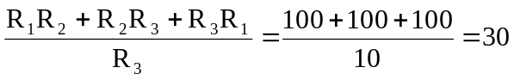
R_{a} = R_{b} = R_{c} = 30 Ω

- 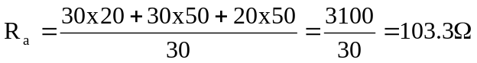
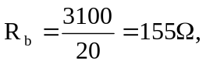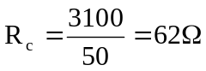
R_{a} = 103.3 Ω, R_{b} = 155 Ω, R_{c} = 62 Ω

